Requirements for Portflow Evidence Section

A system where students can create and maintain a structured portfolio.

* A student can add multiple kinds of evidence:
  + LMS assignment submissions - imports of submitted assignments from courses in the LMS,
  + File uploads - can be any type of file, with a max size of 500 mb per file,
  + Links
  + Free text - to create evidence quickly and directly without the need for a local text editor,
  + Video - embedding video from popular video platforms (YouTube, Vimeo),
* Common file types (e.g., .docx, .xlsx, .pptx, .pdf, .jpg, .png, etc,) should be preview-able directly,
* All files can be downloaded from the portfolio,
* Evidence can consist of multiple files per evidence,
* Evidence can have multiple versions, with multiple files per version (feedback is tied to an evidence),
* Evidence can have a name and rich-text description / reflection,
* Evidence can be @mentioned everywhere in the portfolio, generating an active link to evidence,
* Evidence can also be a reflection,
* Evidence section has a search bar,
* Evidence needs to offer goal and collection edit,
* Goals per evidence should be visible too (just like collections) in evidence section overview,
* Filtering of evidence by date, type of evidence etc.,
* Visible feedback status per evidence (request, pending, feedback received or sth alike),
* Evidence should be arrangeable or orderable by type, date,
* Should be possible to upload evidence from google drive,
* Bulk delete options,

Evidence Dashboard

The list of potential features to be added to dashboard in order to improve the current state.

* File map can be used to show where the file is within the structure (tree) or card system to group ‘em,
* Rename the Section to just “Evidence” or “Evidence management” or “Evidence Panel”, ❌
* Option to change view to:
  + List
  + Icons/Cards
  + Detailed list
* Option to sort the contents by: (Date-created is default)
  + Collection
  + Goal ❌
  + Type
* Group by:
  + Collections and their content,
  + File types
  + Goals and their content ❌
  + Course (when uploaded as canvas assignment) ❌
* Filtering (via search field and/or buttons) by
  + Date (from-to)
  + Name
  + Collections
  + Goals
  + Type
* Display evidence details on hover or in a separate section:
  + Name
  + Type
  + Upload date
  + Linked Collections
  + Related Goals
  + Feedback status
  + Comment count
  + Evidence Description
  + # Versions
* A preview section for a faster file management, ❌
* There should be a counter of evidence when filtered,
* Option to remove evidence:
  + One by one
  + Bulk

Designing

Create several versions: start with basic idea and add only a few main features (v1), others make more complex: use cards (v2), use a tree (v3). Start sketching on paper, then transfer to figma.

V1: use existing list view but add + sort by collections, goals, type + display goals and collections and option to edit them + latest feedback status, comment count, # of versions and total feedback count.

V2: card system + details section with goals and counts of comments and feedback etc + duplicate evidence + drag and drop evidence.

V3: tree system of all evidence + no clue, think about it…💭

Perhaps goals and collections can be linked and displayed using below for ideas:

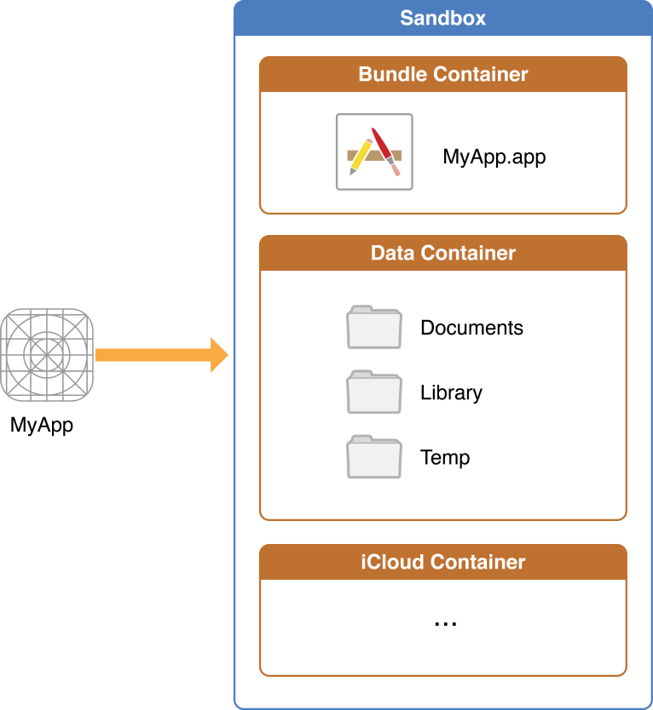 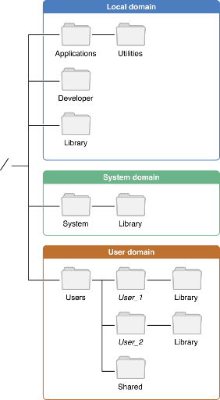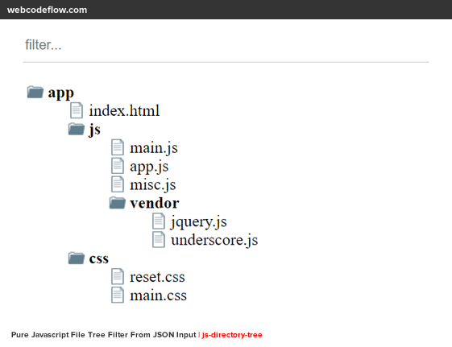

V4: Pieter’s version (combination of cards and list) use a dashboard (control panel) to filter and sort the table below)

V5: Smart Table by antDesign – it can offer same features and more, also combine different filters + add stats summary based on filters applied.

V6: Dashboard with a smart table, for dashboard use StudyCoach Dashboard as inspiration.

V7: Improved V6, that matched the antDesign guidelines better and includes feedback received from stakeholders.

Process

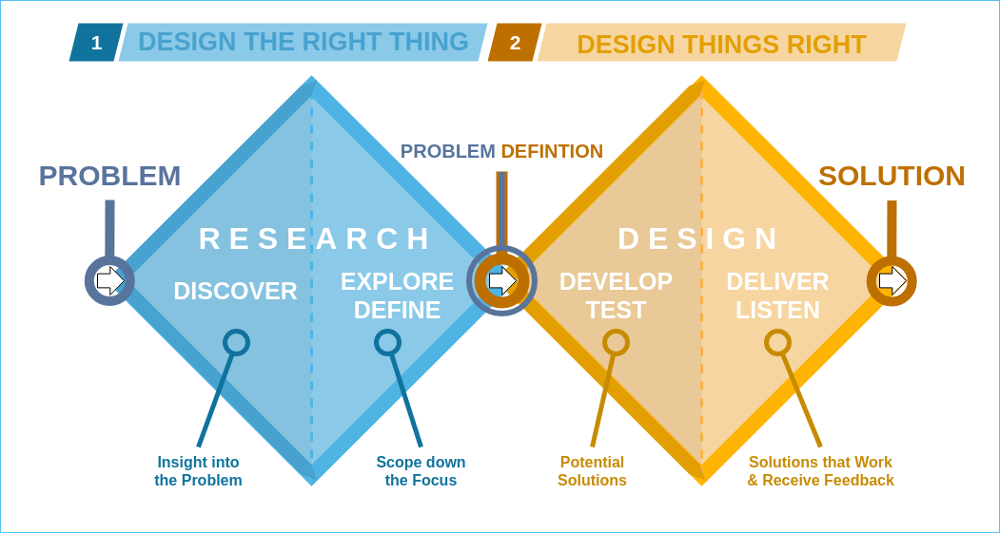

Defined the problems and scope in requirements document (refinement too)

Design diamond happened twice, made first 3 versions, after feedback concluded to one (V4).

Then, received feedback again and diverged into 2-3 more versions again (V5 and V6).

V7 is a convergence of the previous two and has all the improvements from feedback.

Below is a Moscow table for V7: